International Children’s Growth Awareness
Online Educational Campaign
Action Plan
for
Medical Facilities and Societies

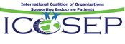
These plan options were prepared for your easy reference by ICOSEP,
the international division of The MAGIC Foundation for children’s growth.

ICOSEP is MAGIC’s network representing hundreds of patient organizations and medical societies around the world. United we create change for all endocrine patients. We warmly welcome you and your facility/society to join this campaign. 10 minutes of time has the potential to change the future of all endocrine challenges.
ContactUs@icosep.org
Why is this Educational Campaign important to you?
Today, we are fortunate that medical research and science have reached such an enlightened level. Never before in the history of medicine have there been so many identified syndromes and potential treatments for our diverse community of patients. Most conditions will overlap endocrinology in some way.

So…..
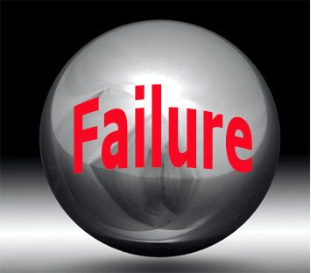
Why does the public fail to recognize Endocrinology?

- We have built our unique medical societies.
- We have helped patient organizations build.
- We have maintained our medical education.
- We have been faithful, devoted and caring and
- Been an important part of our hospital and clinical care….
However, the general public typically have no idea what endocrinology is or how crucial it is to good health.
Compared to other medical specialties, why is the critical importance of endocrinology undervalued?
We have all been distracted and busy about the jobs of saving and improving the lives of our patients. Who would have ever thought that being a dedicated, ethical, trained medical person or administrator would one day hurt our future? It’s just crazy! I doubt there is any medical expert who would ever question the real need of endocrinology….but what about the hospital administrator? He or she probably knows very little about the topic. And funding for our departments…well that is just a problem around the world. But if one of those high-level administrators has a child with a rare endocrine condition-your title, respect and operating budget probably see an increase quickly!
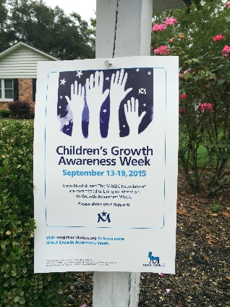
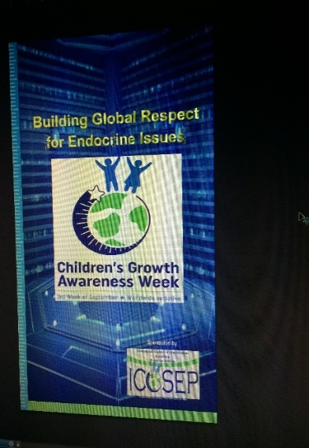
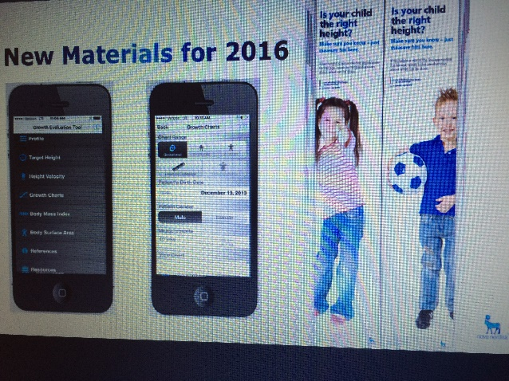
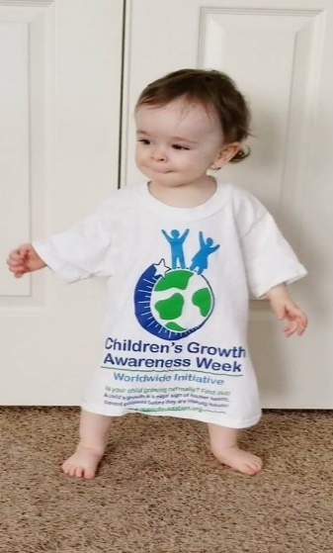
Today, we have reached a point in our history
where we must choose;
- Are we going to remain quiet and keep our heads down simply doing our jobs? Or
- Are we going to allocate 10 minutes once a month to ensure our entire Endocrine future is solid and continues to strengthen?
Some people will be happy to simply have things remain the same. ICOSEP members are not those people. We are uniting our voices in a non-political manner, (not representing a specific disease or a specific treatment) for the good of all endocrine patients and recognition of this profession.
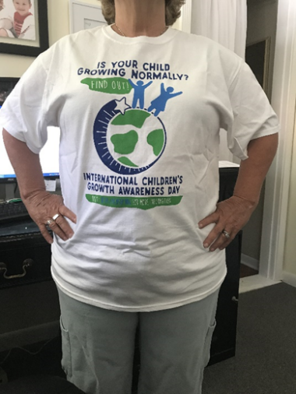
Once each year, we share a simple message which teaches the public about the importance of children’s growth. We do this because children’s growth is signal for more than one thousand rare endocrine based conditions. Uniting them under one network gives power to our real challenges and a voice to those suffering as well as our societies and work departments. We are not a promotional tool. With this campaign we remain an ethical, hardworking dedicated team for the good of all endocrine patients.
Societies, hospitals, governments and others who have joined this effort have been surprised at the reaction from families when they first begin their own local educational campaigns.
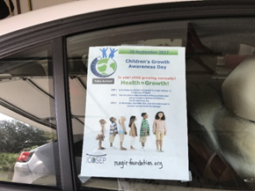
The public responds positively and quickly to acts of generous compassion and they share the lessons you teach them with friends. They learn about children’s growth, what to do if they suspect a problem, and they remember your society or hospital is the one who was caring and helped them get help for the most important people in their lives…their children!
By participating in this campaign, you strengthen your community awareness of the medical issue, and become an important active part of the network which will change medical history!
Levels of Participation
Medical societies, hospitals and patient organizations come in a variety of sizes. Some groups are large with many people, others are smaller. Therefore, we offer 2 levels of participation to meet your organization’s needs.
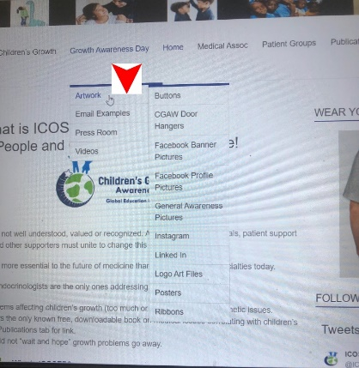
Option #1
Simple, prebuilt artwork in many languages and cultures is free on our website for you to download.
To view the options for your country visit: http://icosep.org.
Hover over the Growth Awareness Day tab so that the “Artwork” tab shows. Then simply click on the artwork topic of your choice.
- Choose artwork from the options.
- Download the item(s).
- Add your organization’s logo and contact information.
- Share the finished item(s) on your social media areas on 20 September.
- Please send us a copy of your work so that we can share it with the world! Thank you!
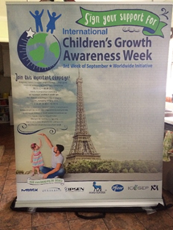
Option #2
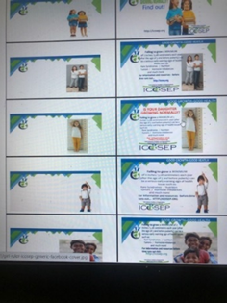
Detailed
Artwork is available to you at no cost. Categories of art are generic, or for specific languages and countries. We have buttons, doorhangers, LinkedIn, Facebook, Twitter, Instagram, posters and other artwork. Simply capture the files that you like, add your logo and use it for Children’s Growth Awareness day. Promote your clinic, hospital or organization.

The following pages are a lengthy and detailed Calendar guide for organizations who wish to give their community a thorough idea of children’s growth. It is not necessary to do such a large campaign but it is helpful in teaching your community about endocrinology and the value of your organization. Despite the length of this guide, the amount of time required to accomplish this entire campaign, is typically only a few minutes each day.
If you need assistance; email ContactUs@icosep.org. We will be happy to assist as possible. Ten minutes, changes the reputation of endocrinology and changes the lives of patients. It also teaches the world how important your jobs and societies are to the health of citizens. Together we can change the relevance of endocrinology throughout the world.

